

รายงานข้อเสนอโครงงานทางวิศวกรรม (ข้ามสาขาวิชา)
(Senior Project Proposal Report)
คณะวิศวกรรมศาสตร์ จุฬาลงกรณ์มหาวิทยาลัย

รหัสโครงงาน SP 3

ชื่อโครงงาน
(ภาษาไทย) อัลกอริทึมสำหรับการแก้ปัญหาการส่งเอกสาร
(ภาษาอังกฤษ) Algorithm for solving messenger service problem

รายชื่อสมาชิกกลุ่ม :
ชื่อ – สกุล รหัสประจำตัว ลายมือชื่อ
3.1. นาย ปรัชญา เอี่ยมทรงศักดิ์ 5730327221 …………………..
3.2. นาย ภคภูมิ ปธานราษฎร์ 5730430121 …………………..
3.3. นาย วสุวัชร สถิตธรรมจิตร 5731095821 …………………..

รายชื่ออาจารย์ที่ปรึกษาโครงงาน
‘ ตำแหน่งทางวิชาการ/ชื่อ – สกุล ลายมือชื่อ
4.1 ผศ.ดร.มาโนช โลหเตปานนท์ (..................................................)
4.2 ผศ.ดร.อรรถสิทธิ์ สุรฤกษ์ (..................................................)

- หลักการและเหตุผล (ที่มาและความสำคัญของปัญหา)
Bangkok is full of businesses and companies, and even more companies today due to the booming of startups. Therefore, the demands of the messenger services are high. Moreover, Bangkok is also full of bike taxis (Win-motorcycle, motorcycle depots) which is good for us. However, the existing messenger services have some downsides. For example, the traditional messenger services generate all requests separately (1 job = 1 request). However, in the system we are trying to develop, the requests will be combined to minimize total travel distances (1 job can be many requests from many users). We will not have bike depots considered at this point because we assume that bikes are everywhere in Bangkok, but we will separate requests into groups to generate jobs for deliverymen to take, and when all jobs are generated, the deliverymen can choose the nearest jobs to do. This is the advantage of our system because the bikes (deliverymen) can do many requests in one job with fewer distances than existing systems, assuming that the bikes have to return to their depots. For more understanding, please see the pictures below.
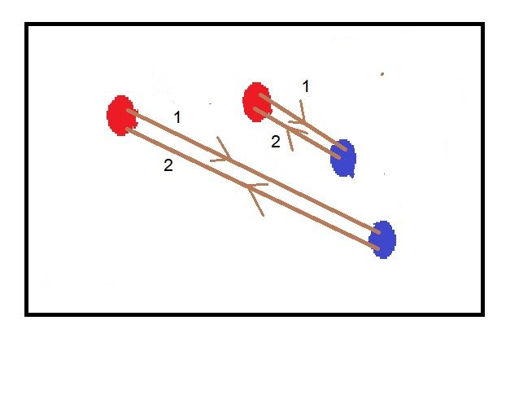
Fig. 1.1 – The existing system. 2 job 2 requests; Red nodes are pickup points; blue nodes are delivery points.
Assume that bikes have to travel to pickup points (red nodes), then to delivery points (blue nodes), then to their depots, which is somewhere near the pickup points (the lowest distances case is that the depots are at pickup points).

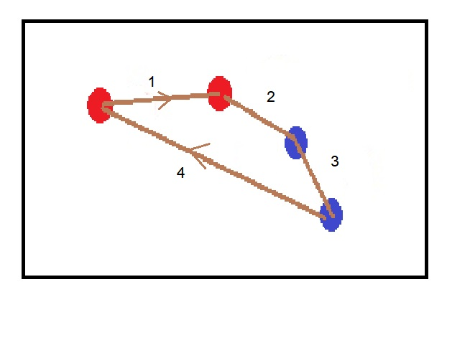
Fig. 1.2 – The existing system. 1 job, 2 requests.
The requests are combined into 1 job, the total travel distances are decreased.

- วัตถุประสงค์ของโครงงาน
The objective of this project is to find and analyze an algorithm for the messenger service problem. The messenger service is a service which users have requests to send documents, and service providers (deliverymen) pick the documents from users at the pickup points and deliver them to the delivery points. This problem can be classified as a pickup and delivery problem. Given, the requests from users (the pickup points, the delivery points, time windows, etc.), we want to generate jobs (the tours of vehicles) for the service providers (deliverymen) with the lowest costs (travel distances) and still satisfy the constraints. Our objective is to find a way to generate the best jobs.

- ทฤษฎี/ งานวิจัยที่เกี่ยวข้อง
The Pickup and Delivery Problem (PDP) is a problem that the objective is to construct the optimal routes that satisfied all transport requests and constraints. It is classified as a NP-hard problem; since the problem can be viewed as a Vehicle Routing Problem (VRP) with precedence constraints (e.g. node i have to be visited before node j) which is NP-hard, also VRP is the general case of the well-known Traveling Salesman Problem (TSP), which is also NP-hard. Therefore, many researchers have used heuristics and meta-heuristics to solve this kind of problems rather than exact methods. There are many variations of the problem that we will review below.
(note: all articles have the vehicle ‘load capacity’ in their constraints)
//To do Lit. review-------------------------------------------------------------------------------------------------------------------------------------------------------------------

For the PDP with time windows (PDPTW) and handling operations (one depot), branch and price and cut technique was also used[1], but computational time was rather expensive (96 requests in up to 2 hours).
Next, for the Multi-Depot and Multi-Vehicle PDP (m-MDPDPTW), E. Ben Alaia and Imen Harbaoui Dridi et al. use GA to solve this problem[2] (E. Ben Alaia, Optimization of the Multi-Depot & Multi-Vehicle Pickup and Delivery Problem with Time Windows using Genetic Algorithm, 2013). They later extend the problem to multi-objective (minimize travel distance, tardiness time, and vehicles number) PDPTW[3] and solve it with GA hybrid with Pareto Dominance Optimization. Later, the bi-objective (minimize travel distance and tardiness time) dynamic PDPTW[4] solved with GA hybrid with aggregation method.
For the VRP problems, there are articles[5] [6], that show the superiority of ACO over GA in terms of solution qualities.
Swarm Optimization are also used to solve PDP and VRP, there is a literature review for this topic.[7]
//To do Lit. review-------------------------------------------------------------------------------------------------------------------------------------------------------------------

- ขอบเขตของโครงงาน
The scope of this project includes studying research papers from the past, researching and developing our own algorithm for the problem, simulating and running test cases. We will not intend to develop an actual mobile application in this project.
About the problem, we are trying to find the best ways to generate jobs for service providers (deliverymen); each job consists of request(s) from user(s) who want to send documents, given traveling distances between places, time windows that users appoint to receive the documents, coordinates of places. We want to generate the jobs with the lowest total travel distances. We are focusing on documents messenger services, so the problem will have no load capacity constraints for the vehicles. We also assume that the amount of bikes in Bangkok are high enough so that we do not have to think about constraints of the number of vehicles, and there will always be a bike (deliveryman) who accepts any jobs we created.

- รายละเอียดการดำเนินงานโครงงาน
First, we have studied research papers about the subject. Next, we will try to get clearer requirements and constraints for our own project. After that, we will try to formulate our problems and come up with the algorithms to solve them. Finally, we will simulate the situations and test them on computers to get the conclusion.
Apart from the study papers we reviewed, we found that Google has the Google Maps API that can get time and distance on the roads between places. We think these tools might be useful later in the project (e.g. making practical test cases using real distances and real traveling times, drawing the solution paths on the real map, etc.).
We also tried to get a hands-on experience in solving these kinds of problems, so we tried to solve TSP, visualize them and plot all the nodes and solution path, as can be seen below.

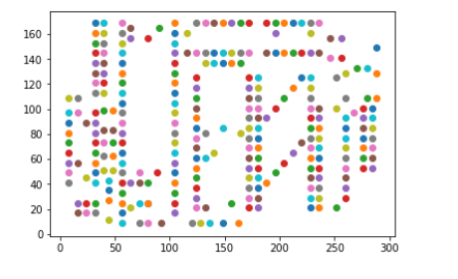
Fig.5.1 – TSP: All nodes to solve.
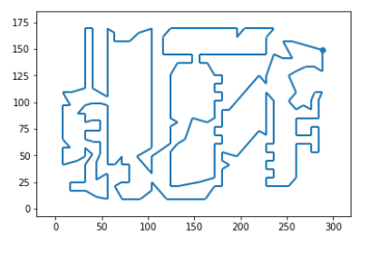
Fig 5.2 – TSP: The solution path (solving by Google’s ORTools).

About the test instances, we have Li and Lim’s and Cordeau’s PDP instances to test our effectiveness of algorithms. These instances were used for benchmarking in some research papers. However, the results cannot be directly compared with those from the papers, since the objective, constraints, and details are not the same.

- ประโยชน์ที่คาดว่าจะได้รับ
- To develop the algorithms for solving the practical problem.
- To learn more about algorithms.
- To work as a team.

- เอกสารอ้างอิง
[1] Marjolein Veenstra, M. C. (2016). The pickup and delivery problem with time windows and handling operations.
[2] E. Ben Alaia, I. H. (2013). Optimization of the Multi-Depot & Multi-Vehicle Pickup and Delivery Problem with Time Windows using Genetic Algorithm.
[3] E. Ben Alaia, I. H. (2014). Genetic Algorithm with Pareto Front selection for Multi-Criteria Optimization of Multi-Depots and Multi-vehicle Pickup and Delivery Problems with Time Windows.
[4] Imen Harbaoui Dridi,E. Ben Alaia, P.Borne (2015). Heuristic Approach for the Optimization of The Dynamic Multi-Vehicle Pickup and Delivery Problem with Time Windows.
[5] Nature-inspired Heuristics for the Multiple-Vehicle Selective Pickup and Delivery Problem under Maximum Profit and Incentive Fairness Criteria. (n.d.).
[6] R. J. Kuo and Ferani E. Zulvia (2017). Hybrid Genetic Ant Colony Optimization Algorithm for Capacitated Vehicle Routing Problem with Fuzzy Demand - A Case Study on Garbage Collection System.
[7] Jyoti Gupta, Chander Diwaker (2015). Vehicle Routing Problem using Swarm Optimization Techniques.
//To do Lit. reference-------------------------------------------------------------------------------------------------------------------------------------------------------------------

